Suppose we have a file system that stores both files and directories. An example of one system is represented in the following picture:

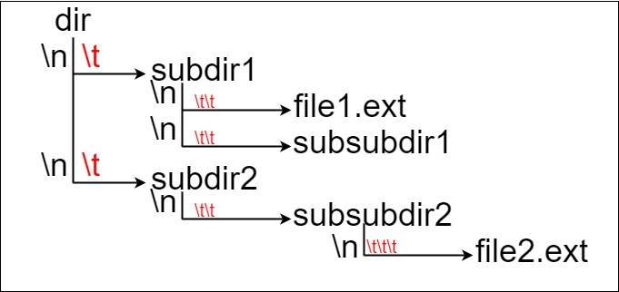

Here, we have dir as the only directory in the root. dir contains two subdirectories, subdir1 and subdir2. subdir1 contains a file file1.ext and subdirectory subsubdir1. subdir2 contains a subdirectory subsubdir2, which contains a file file2.ext.

In text form, it looks like this (with ⟶ representing the tab character):

dir

⟶ subdir1

⟶ ⟶ file1.ext

⟶ ⟶ subsubdir1

⟶ subdir2

⟶ ⟶ subsubdir2

⟶ ⟶ ⟶ file2.ext

If we were to write this representation in code, it will look like this: "dir\n\tsubdir1\n\t\tfile1.ext\n\t\tsubsubdir1\n\tsubdir2\n\t\tsubsubdir2\n\t\t\tfile2.ext". Note that the '\n' and '\t' are the new-line and tab characters.

Every file and directory has a unique **absolute path** in the file system, which is the order of directories that must be opened to reach the file/directory itself, all concatenated by '/'s. Using the above example, the **absolute path** to file2.ext is "dir/subdir2/subsubdir2/file2.ext". Each directory name consists of letters, digits, and/or spaces. Each file name is of the form name.extension, where name and extension consist of letters, digits, and/or spaces.

Given a string input representing the file system in the explained format, return *the length of the****longest absolute path****to a****file****in the abstracted file system*. If there is no file in the system, return 0.

**Example 1:**

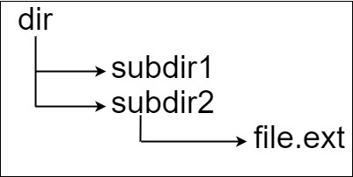

**Input:** input = "dir\n\tsubdir1\n\tsubdir2\n\t\tfile.ext"

**Output:** 20

**Explanation:** We have only one file, and the absolute path is "dir/subdir2/file.ext" of length 20.

**Example 2:**

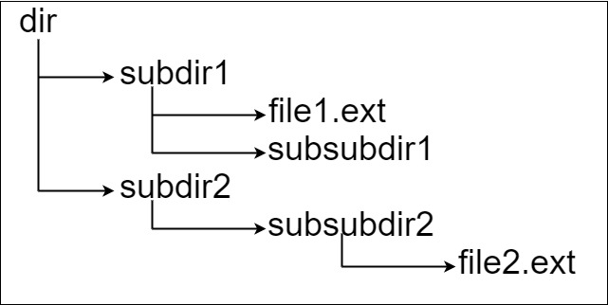

**Input:** input = "dir\n\tsubdir1\n\t\tfile1.ext\n\t\tsubsubdir1\n\tsubdir2\n\t\tsubsubdir2\n\t\t\tfile2.ext"

**Output:** 32

**Explanation:** We have two files:

"dir/subdir1/file1.ext" of length 21

"dir/subdir2/subsubdir2/file2.ext" of length 32.

We return 32 since it is the longest absolute path to a file.

**Example 3:**

**Input:** input = "a"

**Output:** 0

**Explanation:** We do not have any files, just a single directory named "a".

**Example 4:**

**Input:** input = "file1.txt\nfile2.txt\nlongfile.txt"

**Output:** 12

**Explanation:** There are 3 files at the root directory.

Since the absolute path for anything at the root directory is just the name itself, the answer is "longfile.txt" with length 12.

**Constraints:**

* 1 <= input.length <= 104
* input may contain lowercase or uppercase English letters, a new line character '\n', a tab character '\t', a dot '.', a space ' ', and digits.